Techno Machine Tools
Survey no:126/A/1, DOOR NO: 4-132-9/A/2, Gandimaisamma X Road,
Medchal Malkajgeri,Hyderabad-500043.Telangana, India.

(MANUFACTURERS OF ROLL FORMING MACHINES)

T.SIVARAMAKRISHNA
ME., MBA.
---------------------------------------------------------------------------------------------------------------------------------
TMT/ Pawan Gupta/S0720/2026 24-03-2026

To
Pawan Gupta,
Mobile No :+919628535180
Dear sir,

Sub :- Supply of roll forming machine for shutter patti 127 mm strip width

With above reference we are here with giving our least price as under.

S No | Description of the unit | Offer
1. | Roll forming machine with 127 mm width thickness 0.7 mm to 1.2 mm along with gear box and 5 hp Crompton Motor along with 8 passed gear box drive | Rs 3,60,000/-  (Rupees Three Lakhs Sixty Thousand Only)

Note:
Rolls are hardened.

GENERAL TERMS & CONDITIONS:

- Price quoted per unit ex-work. Hyderabad.
- Following charges are additional to your account.
- Freight Charge : As actual to be borne by you.
- GST : 18% Extra as applicable
- Packing charge : As actual to be borne by you.
- Insurance : As actual to be borne by you.
- Payment : 50% advance along with order balance before delivery but after inspection at our works.
- Delivery : within 3-4 weeks.
- Validity : One month from the date of submission.
- Inspection : Inspection at our works prior to dispatch.
- Warranty : The machine is warranted for a period of 12 months from the date of dispatch against any manufacturing defects/ faulty material or bad workmanship of any part or component but not against any kind of abnormal or improper use of machine. Defective part or component will be replaced or repaired free of cost. Electrical components are outside the scope of this warranty.
- Commissioning : Erection & commissioning done by you, but required technical support & guidance provide by us at additional cost.

NOTE:
- Oil is not in scope of our supply.
- Raw material for trial is to be arranged by you at your cost.

We are sure you will find our offer in line with your requirements. Should you require any further clarification please contac T.SIVARAMAKRISHNA Mobile: 9246221106. Email: srktalam@gmail.com

Thanking you and assuring you of our best services.

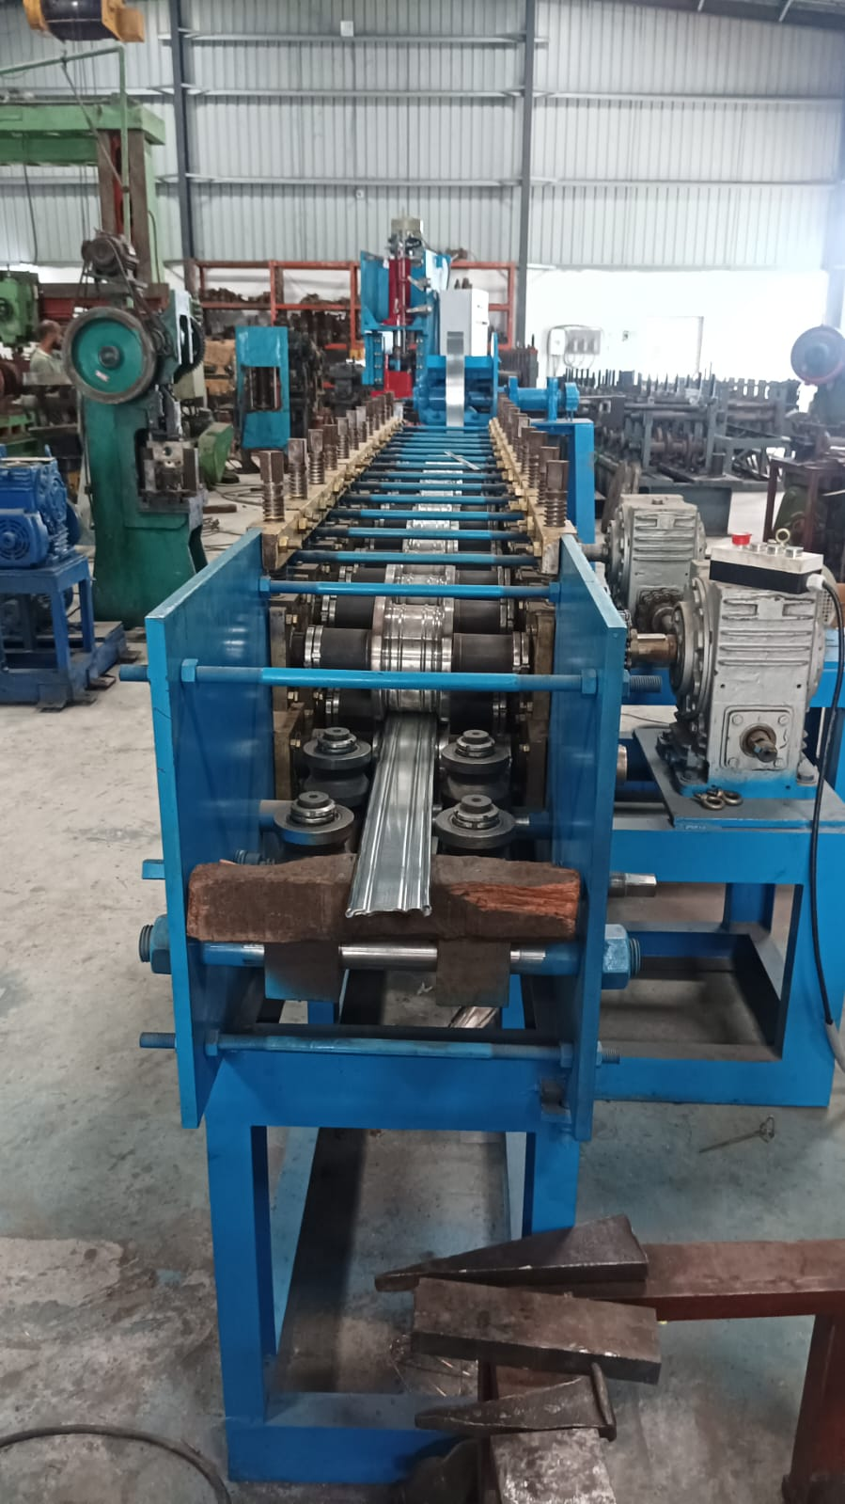

For TECHNO MACHINE TOOLS

( T. SIVARAMAKRISHNA)

